**Module 3:** **Online Frauds and Examples of Cyber Threats LESSON PLAN** 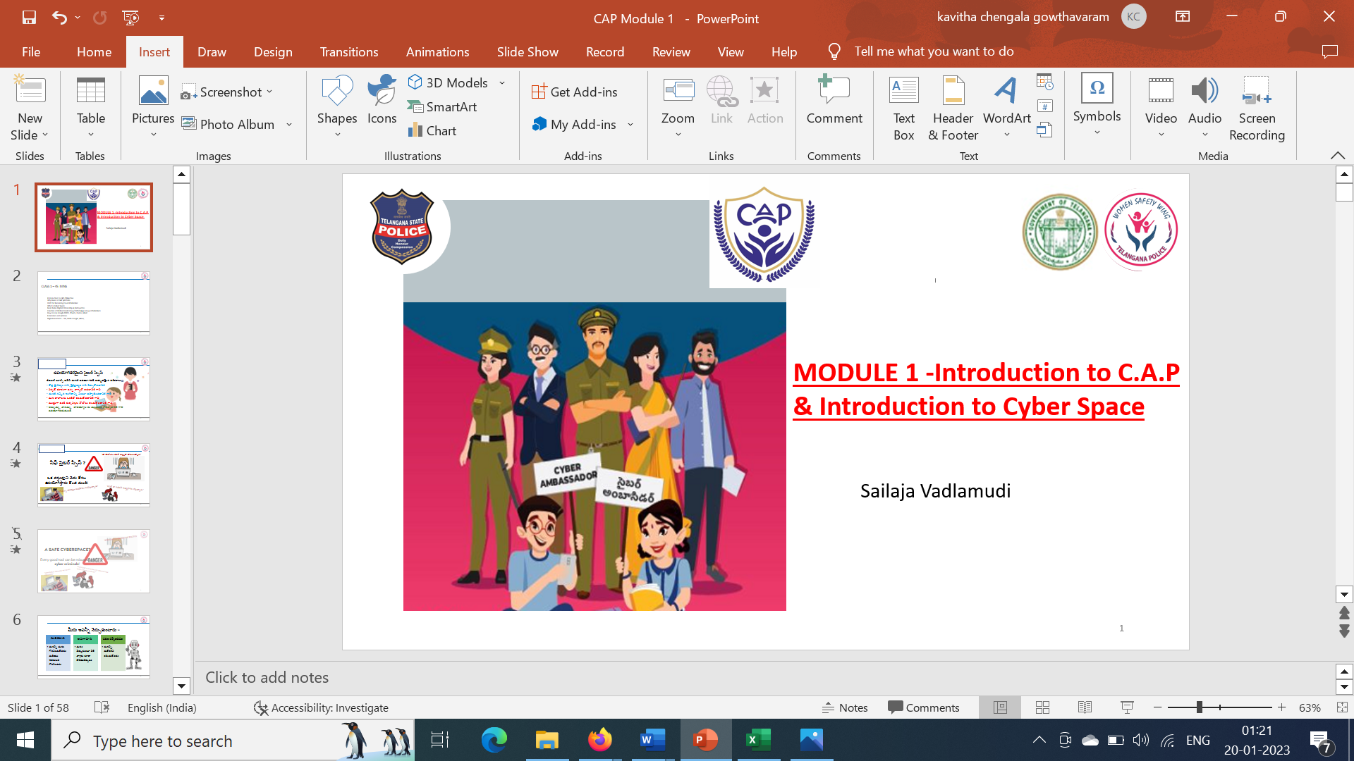

**Learning Outcome**

|  |
| --- |
| On successful completion of the module, learners: |
| **Knowledge :** |
|  |
| ·       Awareness on the Cyber Crimes and Online Frauds |
| ·       Awareness on the Phishing attacks on emails & messages - How to find fraud emails |
| ·       Identify and list the different types of cyber-Bullying, Cyber Trolling and Cyber sexting |
| ·       Recognise the UPI Frauds |
| ·       Recognise the unsafe games to stay away like Blood Shed , Stealing, Hitting , Tasks |
| **Skills :** |
| ·       Collaborate effectively with different stake holders like mentor teachers, trainers, she team officers, officer in charge, volunteer mentors |
| ·       Apply effective oral, written, and visual communication skills to create awareness on cyber safety |
| **Application of knowledge and skills :** |
| ·       Apply the skills and knowledge gained to the protect the community, family and friends from cyber crimes and online frauds |
| ·       Appraise the students, friends on unsafe addictive games |
|  |

**LESSON PLAN ;**

|  |  |  |
| --- | --- | --- |
| **LESSON NAME /SUBTOPIC** | **MODE /TIME REQUIRED /PPT/ OTHER TEACHING TOOLS** | **EQUIPMENT REQUIRED /ACTIVITY /TIME** |
| Pre assessment | Pre assessment -5 questions (MCQ) to understand the knowledge of the students | **Zoom poll survey -5 min ..** |
| Creating awareness on the WOMEN SAFETY WING and district SHE TEAM OFFICERS group pic with names of each zone | Group pic of WOMEN SAFETY WING officers and District SHE TEAM OFFICERS pic | **PPT with 2 group pics with names -3 min** |
| Ice breaker - video on most wanted hacker | <https://youtube.com/shorts/Mpzr-JzSCoo?feature=share> | **Video – 2.3 min** |
| Ice breaker – video on UPI frauds | NCPI video on online frauds | **Video – 2 min** |
| * Recap of Module-2 | **Quiz through 5 questions ( giving opportunity to the fastest 10 responses, and then later revealing the correct response )** | **5 min** |
| * Introduction to Online Frauds | SLIDE 3 | **20 min** |
| * Phishing attacks on emails & messages - How to find fraud emails | SLIDE 4 to 24  Real time Case study of Cyber bullying  Real time Case study of  Cyber Trolling  Real time case study of cyber sexting  Real time case study of cyber defamation |
| * Vishing Attacks |
| * Cyber Bullying, Trolling, Sexting, Defamation |
| * Online Games and Frauds | Slides 25 to 30 | **10 min** |
| * Mobile phone hack | Slides 31 to 32 | **2 min** |
| * UPI Frauds | Slides 33 to 36 | **5 min** |
|  |  |  |
| Post Assessment explanation | The timeline for completing the post assessment shall be given like an hour from the end of the session. Cyber Ambassador have to log in to the website and answer the questions. There are 10 questions pertaining to the syllabus. | **2 min** |
| Activity 1 and 2 Narration | Time line to complete this activity is 3 weeks from the time of completing the second module .Narration given below . | **3 min** |

**Recap of module 2 quiz questions :**

1. Choose the best way to make your Facebook account private and secure?
2. Tag friends in every post
3. Use security applications
4. Make a strong password ( ans)
5. Go intermittent offline
6. Which of these is not a privacy feature on WhatsApp?
7. Check up
8. Last seen
9. Live location
10. About ( ans)
11. If hackers gain access to your social media accounts, they can do some illicit or shameless act to degrade your reputation.   
    a) True (ans)  
    b) False
12. Which of these is a way to increase your security for social media account ?  
    a) signing in  
    b) logging out ( ans)  
    c) signing up  
    d) logging in

**PREASSESMENT QUIZ QUESTIONS :**

**Mode : Zoom poll which can give the percentage of yes or no is used to assess the knowledge and experience of students in cyber space**   
**Questions :**

**POSTASSESMENT QUESTIONS**

**ACTIVITY IN CYBER AMBASSADOR PLATFORM (C.A.P)**

**CybHER # Cybersafe For Her**

**ACTIVITY TITLE 1 for module 3 : Role play on Prevention of Cyber bullying**

**PARTICIPANTS:** Cyber Ambassadors, Students

**WHEN IS THIS DONE:** After the third module session the activity shall be finished within 2 weeks’ time

**MODUS OPERANDI: Do a role play on how to prevent cyber bullying or trolling or defamation**

**LANGUAGES**: English or any local language or bilingual as well

**ACTIVITY VIDEOS AND PICS** : To be shared with us through jot forms as and when provided

**OUTCOME OF THIS ACTIVITY:** To make students aware of the bad impacts of cyber bullying , sexting and trolling .

**ACTIVITY TITLE 2 FOR Module 3:** Identify the monetary fraudsand create awareness to your students

**PARTICIPANTS:** Cyber Ambassadors

**WHEN IS THIS DONE:** After the third module session the activity shall be finished within 2 weeks’ time

**MODUS OPERANDI:** Take screenshots of different types of frauds (messages) that involve money laundering and get a print out and paste on a chart paper with a creative preventive message to save from monetary frauds**.**

**LANGUAGES**: English or any local language or bilingual as well

**ACTIVITY VIDEOS AND PICS** : To be shared with us through jot forms as and when provided

**OUTCOME OF THIS ACTIVITY:** To make students aware of the messages that can make involve money laundering .